Step by Step: Creating SDTM Annotated CRFs

|  |  |
| --- | --- |
| Glossary | The following are definitions used in this document. |

|  |  |  |
| --- | --- | --- |
| **Term** | | **Definition** |
| ASB | | Annotated Study Book |
| acrf.pdf | | Annotated Case Report Form |
| eCRF | | Electronic Case Report Form |
| Purpose | | To assist anyone responsible for preparing SDTM Annotated CRFs with detailed instructions for creating annotations using Adobe Reader. | |

|  |  |
| --- | --- |
| Scope | The annotated Case Report Form (acrf.pdf) is a PDF document that maps the data collection fields used to capture subject data to the corresponding SDTM domains and variables or discrete variable values contained within datasets. |

|  |  |
| --- | --- |
| **Note** | Adobe Reader XI was used to illustrate the steps and may differ from the version of Adobe currently installed on your PC. See Appendix A for more information regarding requesting and installing Adobe Reader on your machine. |

Table of Contents

Glossary 1

Purpose 1

Scope 1

1. Preparing to Start 2

2. Getting Started 3

3. Default/Modify Settings for Annotation Text Box 7

4. Using Data Element Definitions (DEDs) to Assist with Creating Annotations 11

Appendix A: How to Request and Install Adobe Reader 16

Revision History 17

# Preparing to Start

For InForm Studies Using Central Designer

Obtain a copy of the Central Designer study book (a collection of study specific unique CRFs) with no annotation information. Refer to Study Build Process Document: Annotated Study Book Options. Instruct the Study Build personnel providing the study book to select the “No Annotated Information” display option from the Annotated Study Book Options.

For Studies Not Using InForm/Central Designer

For studies that have used other platforms/systems ensure that the study book you will be using to create the SDTM annotated CRF is free from extraneous information (e.g., raw data annotations).

It’s important that the study book to be annotated is free from extraneous information for several key reasons:

* It provides more space on the CRF page to add SDTM annotations
* The appearance of the CRF page is less cluttered to a regulatory reviewer
* It reduces the chance that a regulatory reviewer will ask for additional information (such as a request to see the raw datasets if the clinical database annotations are included)

NOTE: Throughout this Step by Step document there are references to the Lilly Biometrics SDTM Annotated CRF Guidelines which are located on the [Business Document Repository](http://lillynetcollaboration.global.lilly.com/sites/CDFTProcess/Business%20Document%20Repository/Forms/AllItems.aspx) under the Topic:  Deliver Observed Data => SDTM aCRF. These guidelines are to be used by anyone responsible for the development and delivery of SDTM Annotated CRFs to ensure they conform to industry guidance and are prepared in a consistent manner across the organization.

# Getting Started

| **Step** | **Action** |
| --- | --- |
| 1 | Launch Adobe Reader. Open your Study Book by selecting **File** => **Open.** Navigate to the location where the study book has been saved and select it. |
| 2 | Confirm that the study book has commenting rights enabled. With the study book open:   1. Select File => Properties 2. Select the Security tab 3. Verify that Commenting = Allowed under Document Restrictions Summary   If commenting rights are not enabled, then contact the individual who provided the study book (typically a Clinical Data Manager or Study Build Programmer) and request that it be saved with commenting rights enabled. |
| 3 | Select **Comment (see Figure 1)** from the toolbar on the right hand side of the screen. This will display both the Annotations and Drawing Markups tools shown in Getting Started Step 4. Alternatively, choose **View** from the menu bar and then select **Comment (see Figure 2).** Choose both Annotations and Drawing Markups from the dropdown list.    **Figure 1**    **Figure 2** |
| 4 | The Annotations and Drawing Markups tools should be displayed on the right hand side of the screen as shown below:    Note: These are the tools that will be used to create the annotation text box and the annotation text. |
| 5 | Enable the **Properties** Dialog Box.  Select **View** from the Menu Bar => **Show/Hide** => **Toolbar Items** => **Properties Bar**    The Properties dialog box is displayed.    Note: This will be used to modify both the Annotation Text and Text Box properties. |

# Default/Modify Settings for Annotation Text Box

| **Step** | **Action** |
| --- | --- |
| 1 | To create a new annotation text box:  Select the **Text Box** icon from the **Drawing Markups** toolbar.    The following pointer is displayed indicating the text box has been selected: |
| 2 | Draw a text box by clicking on the study book page and dragging the mouse to create the text box.  The text box should resemble the following.    Note: The text box can be moved and resized later to ensure that it is properly placed in the acrf.pdf and that it fits properly around the text. |
| 3 | To modify the properties of the text box, hover anywhere over the text box until a triangular pointer is present; then single click to activate the text box.  Activated Text Box (below):    Once the text box is activated, then the Text Box Properties dialog box is enabled to allow the user to set the following attributes:     * Line Style: Unbroken Straight * Line Color: Black * Opacity: 100% * Line Thickness: 1 pt * Fill Color (see below chart):   **IMPORTANT:** These are the required attributes that must be used as defined in the Lilly Biometrics SDTM Annotated CRF Guidelines.   |  |  |  | | --- | --- | --- | | **Color Coding Scheme** | **HSL Color Model** | **RGB Color Model** | | Primary Color = Blue | Hue: 120  Sat: 240  Lum: 210 | Red: 191  Green: 255  Blue: 255 | | Secondary Color = Yellow | Hue: 40  Sat: 240  Lum: 200 | Red: 255  Green: 255  Blue: 170 | | Tertiary Color = Green | Hue: 80  Sat: 240  Lum: 210 | Red: 191  Green: 255  Blue: 191 | | Quaternary Color = Pink | Hue: 230  Sat: 240  Lum: 217 | Red: 255  Green: 206  Blue: 219 | | Quinary Color = Purple | Hue: 170  Sat: 240  Lum: 216 | Red: 217  Green: 204  Blue: 255 | | Senary Color = Orange | Hue: 170  Sat: 240  Lum: 200 | Red: 191  Green: 170  Blue: 255 | |
| 4 | To enter the annotation text, hover anywhere over the text box until a triangular pointer is present; then double click. This will activate a blinking icon that indicates text can be entered. |
| 5 | Additionally, the Text Box Text Properties dialog box is opened as shown below:    Set the attributes for:   * Text Color: Use **Black** for Domains and **Red** for Variables * Font: Arial, Bold, Italicized * Font Size: Domains = 12; Variables = 10   **IMPORTANT:** These are the required attributes that must be used as defined in the Lilly Biometrics SDTM Annotated CRF Guidelines.  Hint: You need to first enter text into the text box before setting the attributes defined in the Text Box Text Properties. |
| 6 | In order to set these Text/Text Box properties as the default for subsequent annotations, complete the following:   * Activate the text box as defined in Step 3 above and then right click to display the following options:      * Select **Make Current Properties Default**.   Once this step is complete the next annotation text box will inherit the properties assigned. The user will not need to re-define the properties each time.  **REMINDER:** Ensure that the required color coding scheme defined in the Lilly Biometrics SDTM Annotated CRF Guidelines is followed if there are 2 or more domains on a single page. |

# Using Data Element Definitions (DEDs) to Assist with Creating Annotations

| **Step** | **Action** |
| --- | --- |
| 1 | Obtain a copy of the ASB (Annotated Study Book).  The corresponding DED appears as part of the Form RefName (Note: A RefName is simply an internal reference identifier for an InForm object). This indicates the DED that was used to create the CRF. The example below shows that the AE3001 DED was used to create this Adverse Events CRF.    Note: The DEDs are stored on the following collaboration site:  <http://lillynetcollaboration.global.lilly.com/sites/GCDMLibraryManagementTeam/Documents/Data%20Element%20Definitions/Forms/AllItems.aspx>  For more detailed information about DEDs please refer to the Lilly DED Implementation Guidelines which are also located on the above collaboration site under Visualization Type: DED Implementation Guidance/Training. |
| 2 | Locate and open the DED(s) that corresponds to the CRF to be annotated. |
| 3 | Begin by creating an annotation text box in the upper left hand corner of the CRF that will contain the SDTM Domain Code and Domain Name. These can be located in the DED:      **REMINDER:** Ensure that the principles for the appearance of annotations defined in the Lilly Biometrics SDTM Annotated CRF Guidelines are followed. |
| 4 | Create annotation text boxes to contain the variable names. Both the ASB and DED can be used to help determine the corresponding SDTM variable. In the first example below, the first part of the Item RefName for the question “What was the severity of the adverse event?” corresponds to the variable (or Object Identifier – OID) in the DED:  ASB:    Locate the variable in the DED where the OID matches the Item RefName. Note that the Question attribute in the DED matches the question that appears on the CRF. If the Question text from the DED is too long to fit on a CRF, then the Item Prompt text will be used. The Alias Name where Context: SDTM 3.1.2 corresponds to the SDTM variable name in the parent domain:  DED:    This is the text that should be used to create the corresponding annotation text box:    The annotation text box is typically placed to the right of the variable. Note how the text box has been resized to fit the word. |
|  | Hint: To move the text box simply hover over the text box until the following icon is present and single click on the text box to select it. Note: If the cursor is within the box already you will not see the icon change as shown below. Simply click on the outer edge of the box to select the text box.    To confirm the text box is selected you should see the following.    Move the text box to the desired area on the aCRF.  **REMINDER:** Ensure that the principles for the appearance of annotations defined in the Lilly Biometrics SDTM Annotated CRF Guidelines are followed. |
| 5 | The step for defining and creating the annotations for variables that map to Supplemental Qualifiers (SUPP--) domains is similar to the step above. Use the Supplemental Qualifiers domain prefix and the value for QNAM in the Alias Name to define the annotation text:  DED:    aCRF: |
| 6 | The DEDs can also be used to identify the --TESTCD variable names for creating annotations for SDTM Findings domains.  Note that the Mapping Instructions in the DED below indicate that --TESTCD is derived from the SAS Field Name:  DED:    The SAS Field Name is then used to create the corresponding annotation text:  aCRF: |

# Appendix A: How to Request and Install Adobe Reader

The recommended tool for the creation of the annotations is Adobe Reader.

Acrobat Standard/Acrobat Professional are not required in order to create the SDTM annotation text boxes as these tools incur a departmental charge and require approval.

For Lilly provided software please follow the instructions below:

1. Access Individual Software Installation Tool (ISIT): <http://isit.lilly.com/EndUser.html> and enter your LillyNet credentials:

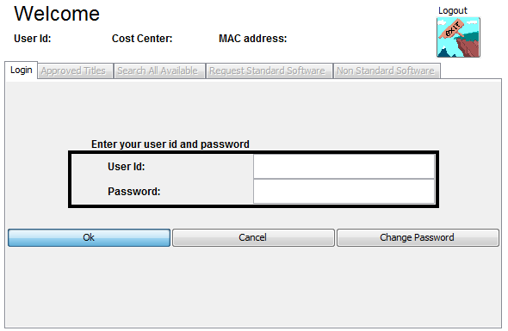

1. In the Search All Available tab enter Adobe Reader in the “Enter a Software Title Name” field and click on the Search button. Highlight the Adobe Reader software title and click the Request button.

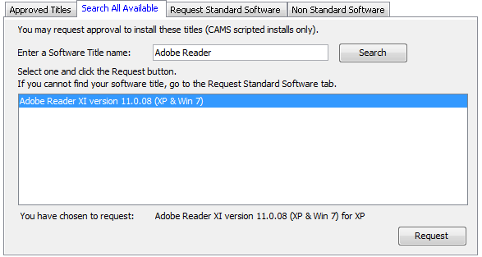

1. Navigate to the Approved Titles tab. Highlight the Adobe Reader selection and click Install!

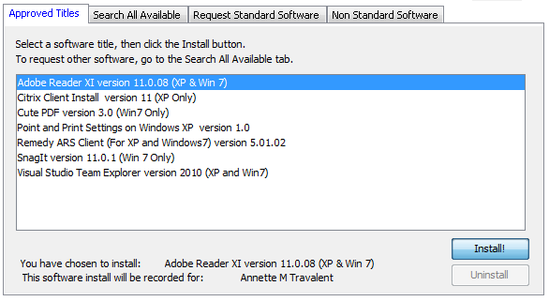

NOTE: For non-Lilly provided software please consult with your company’s IT group for information regarding installation of Adobe Reader.

# Revision History

|  |  |  |
| --- | --- | --- |
| **Version Number** | **Effective Date** | **List of Major Changes** |
| 1.0 | 01Dec2015 | Initial Release |